# Today’s lecture – Create Menu and Shopping Cart for a Pizza Store

We are going to create a website for a Pizza Store.

Below is the example pages

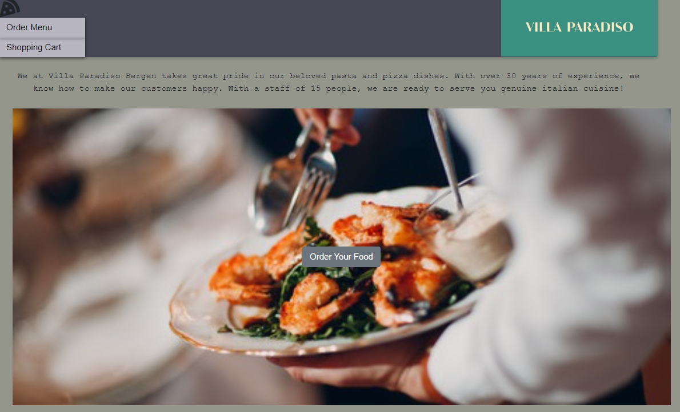

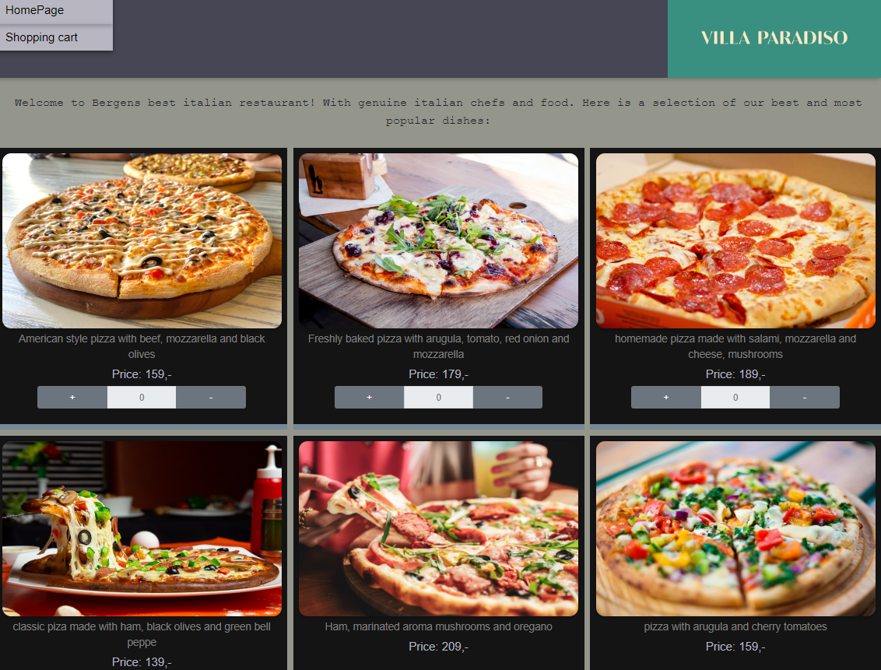

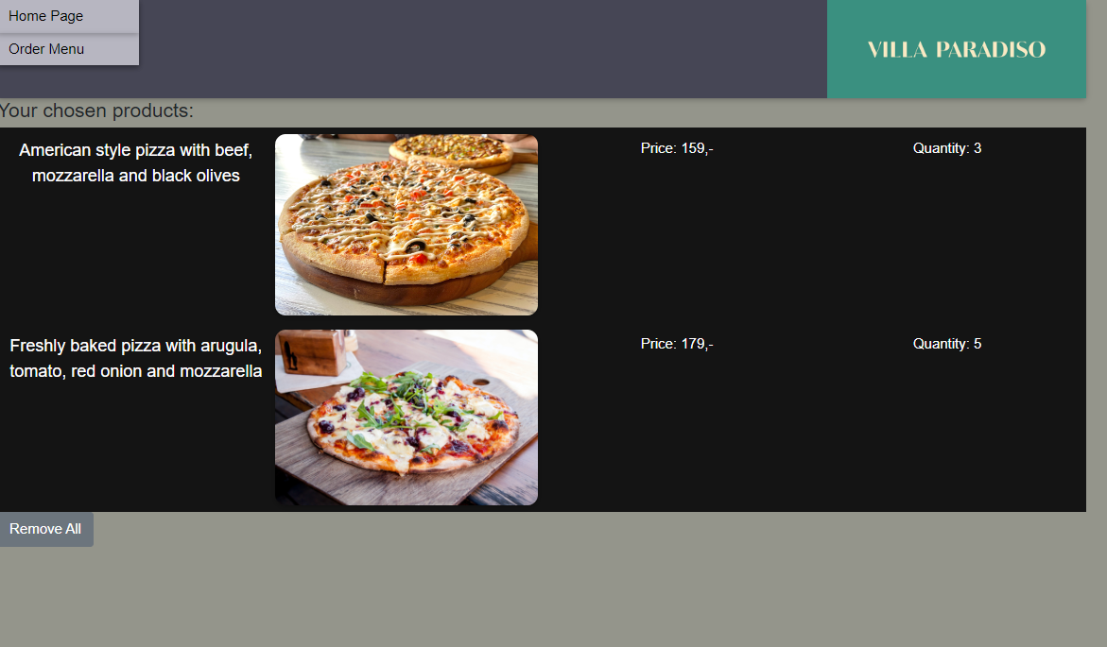

We will use below techniques:

1. CSS
   * Grid / Flex
   * Box model
   * Diverse CSS: color, background-color, text-align, text-decoration, font-family
2. JavaScript ES6
   * Foreach
   * Template literal
   * Filter
   * Sort:
   * Reduce
   * Spread
3. Try Bootstrap
4. Navigation between pages
5. Use LocalStorage to store the selected items in Shopping Cart

Maybe we can think about Creating a “Order” button for each dish, and use Form submit?